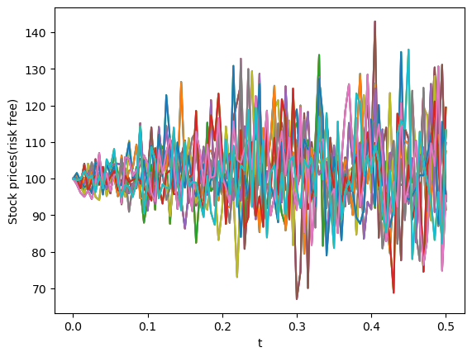
1.

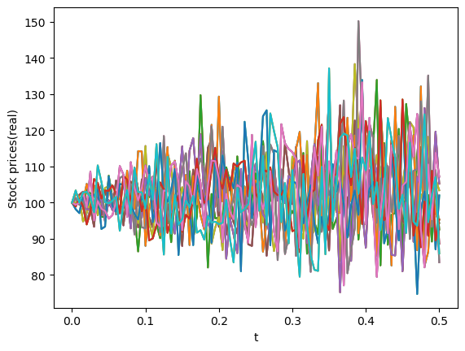

for K=90:
call values=[12.26859665 11.02203887 11.52245361 11.92491752 12.10054095 9.77068605
10.92437598 10.54234833 11.71896768 11.24345017]
put values=[0. 0. 0. 0. 0. 0. 0. 0. 0. 0.]

for K=105:
call values=[0. 0. 0. 0. 0. 0. 0. 0. 0. 0.]
put values=[2.73140335 3.97796113 3.47754639 3.07508248 2.89945905 5.22931395
4.07562402 4.45765167 3.28103232 3.75654983]
for K=110:
call values=[0. 0. 0. 0. 0. 0. 0. 0. 0. 0.]
put values=[7.73140335 8.97796113 8.47754639 8.07508248 7.89945905 10.22931395
9.07562402 9.45765167 8.28103232 8.75654983]
